Lesson 09 AJAX Hands On

**Lesson 9 Hands-On45 points**

**Directions**

In this Hands-On exercise, you will be practicing your new AJAX skills. This Hands-On **will** be graded, so be sure you complete all requirements.

Caution!

Do not submit your project until you have completed all requirements, as you will not be able to resubmit.

Setup

1. Open up your terminal/command prompt.
2. Navigate to your desktop in your terminal.
3. cd Desktop
4. Next, navigate to the FullStackWeb directory in your terminal.
5. cd FullStackWeb
6. Then, navigate to the FrontEndFoundations directory in your terminal.
7. cd FrontEndFoundations
8. Create a new project folder named L09HandsOn located within the FrontEndFoundations folder in your terminal.
9. mkdir L09HandsOn
10. Once the process is complete, navigate into the L09HandsOn directory:
11. cd L09HandsOn
12. Run the following to open your new project in VS Code (or you can open the folder within VS Code directly):
13. code .
14. Create three new files: index.html, script.js, and einstein.json in VSCode by selecting the add file button shown below:

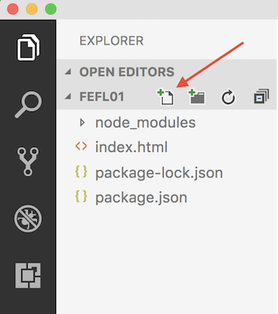

1. Link your JavaScript file to your HTML file using <script src="script.js"></script>

Requirements

For this project, you are going to use AJAX to create a web page that displays a famous historical figure, Einstein, and his information. Follow the below requirements. All JavaScript code should live within the script.js file.

Step 1

* Within the einstein.json file, create a json object that includes the following keys:
  + name with Einsteins full name
  + birthday with Einsteins birth date
  + bio that includes his full bio
* Create a function that will show the name and birthday of Einstein when the page is loaded using the einstein.json file.
* Create a button that will call another function and will display his full bio when clicked.
  + Use the DOM to display the bio
* Don't forget the necessary HTML code to allow this all to work!
* You have to run http-server to correctly see this working or you will get an error.

Caution!

Be sure to zip and submit your entire L09HandsOn directory when finished!